Part A : Debugging (30 marks)
You are given a Java program file in Figure A-1 (GradeCalculator.java) that contains multiple errors, including:
- Syntax errors (e.g., missing semicolons, wrong keywords, incorrect method calls)
- Logic errors (e.g., incorrect conditions or calculations)
- Semantic errors (e.g., data type mismatches, wrong method usage)
Open the file GradeCalculator.java provided to you. Carefully read through the code and identify all the errors that prevent it from compiling and/or producing correct output. Once all errors are fixed, run the program to ensure it displays the correct output. The expected output format is shown in Figure A-2 below.
import java.util.Arraylist;

public class GradeCalculator {

public static void main(String[] args) {
ArrayList studentList = new ArrayList<>();

// Creating students with hardcoded data
Student s1 = Student("Ali", 85, 78);
Student s2 = Student("Beh", 60, 55, 65);
Student s3 = Student("Sara", 40, 50, 45);

// Calculate grades
s1.calculateGrade();
s2.calculateGrade();
s3.calculategrade();

// Add to list
studentList.add(s1);
studentList.add(s1);
studentList.add(s1);

// Display output
System.out.println("--- Student Grades ---")
for (Student s : studentlist) {
s.display ;
}

}
}

class Student {
String name;
double testMark;
int quizMark;
int finalExam;
char grade;

// Constructor
public Student(String name, int testMark, int quizMark, int finalExam) {
this.name = name;
this.testMark = testMark;
this.quizMark = quizMark;
this.finalExam = finalExam;
}

// Grade calculation method
public void calculateGrade() {
int total = testMark + quizMark + finalExam;
double average = total / 3;

if (average > 80)
grade = "A";
else if (average > 60)
grade = 'B';
else if (average > 50)
grade = 'C';
else
grade = 'Fail';
}

public void Display() {
System.out.println("Student Name: " + name);
System.out.println("Test: " + testMark + ", Quiz: " + quizMark + ", Final: " + finalExam);
System.out.println("Grade: " + grade + "\n");
}

public int getQuizMark() {
return quizMark;
}
}
Figure A-1 : GradeCalculator.java

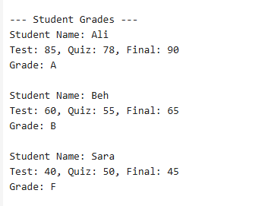
Figure A-2 : Output

